YEAR 12 PHYSICS

SEMESTER TWO EXAMINATION 2002

Name: _________________________

Teacher: _______________________

TIME ALLOWED FOR THIS PAPER

Reading time before commencing work: Ten minutes
Working time for paper: Three hours

MATERIAL REQUIRED/RECOMMENDED FOR THIS PAPER

TO BE PROVIDED BY THE SUPERVISOR

This Question/Answer Booklet
Physics Formulae and Constants Sheet
Sheet of standard graph paper

TO BE PROVIDED BY THE CANDIDATE

Standard Items: Pens, pencil, eraser, correction fluid and ruler

Special Items: Drawing instruments, templates and calculators satisfying the conditions set by the Curriculum Council.

IMPORTANT NOTE TO CANDIDATES

No other items may be taken into the examination room.

It is your responsibility to ensure that you do not have any unauthorised notes or other items of a non-personal nature in the examination room. If you have any unauthorised material with you hand it to the supervisor BEFORE reading any further.

STRUCTURE OF PAPER

Section | No. of questions | No. of questions to be attempted | No. of marks out of 200 | Proportion of examination total
A: Short Answers | 15 | ALL | 60 | 30%
B: Problem Solving | 7 | ALL | 100 | 50%
C: Comprehension and Interpretation | 2 | ALL | 40 | 20%

INSTRUCTIONS TO CANDIDATES

Write your answers in the spaces provided beneath each question. The value of each question (out of 200) is shown following each question.

The Physics Data Sheet must also be submitted with your exam.

Calculators satisfying the conditions set by the Curriculum Council may be used to evaluate numerical answers.

Answers to questions involving calculations should be evaluated and given in decimal form. Quote the final answer to no more than four significant figures. Despite an incorrect final result, credit may be obtained for method and working, provided these are clearly and legibly set out.

Questions containing specific instructions to show working should be answered with a complete, logical, clear sequence of reasoning showing how the final answer was arrived at; correct answers which do not show full working will not be awarded full marks.

Questions containing the instruction estimate may give insufficient numerical data for their solution. Students should provide appropriate figures to enable an approximate solution to be obtained.

SECTION A: Short Answers

Marks Allotted: 60 marks out of total of 200 marks (30%)

Attempt ALL 15 questions in this section. Each question is worth 4 marks. Answers are to be written in the space below or next to each question.

- At a ceremony to commemorate the centenary of Federation, a cannonball was fired horizontally from a cannon at the edge of a cliff that overlooks Sydney harbour. At the moment of firing, an identical cannonball is dropped vertically from the cliff edge.
Assuming that air resistance is neglected, and the cannonballs start from the same height, which cannonball will hit the sea first? Explain.
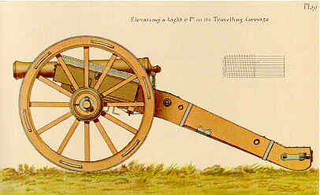
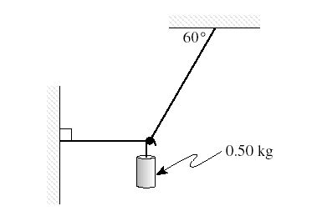
Susan sets up the apparatus below.
What would she find the tension to be in the horizontal string?
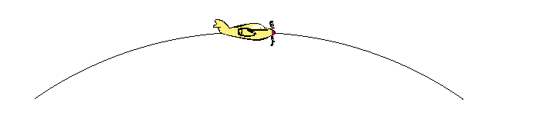
- An aircraft flies in a vertical circular path of radius 2.00 km. At the top of this path the 71.0 kg pilot feels lighter and experiences a 2.00 x 10² N upward force from the seat.
What is the velocity of his aircraft at this point?
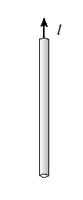
- The diagram below shows a wire carrying a current. Draw in the magnetic field associated with this wire.

- At a recent demolition in Perth, 20 sticks of dynamite were used. If one stick produces a loudness of 90 dB at 20m, what would be the loudness of the 20 sticks at 20m?

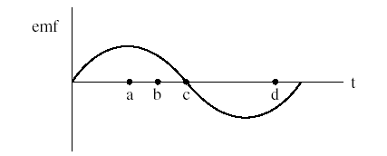
- The graph below shows how the emf produced by an ac generator varies with time. At which point in time is the rate of flux change the greatest? Explain.
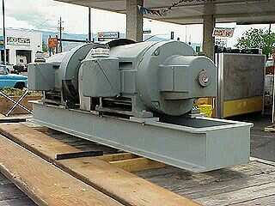

- 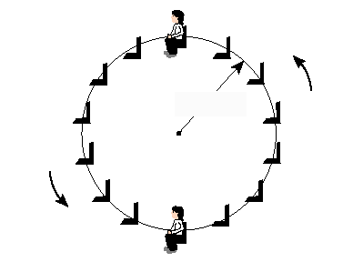Hamish, a Year 7 Physics student is riding the Ferris Wheel at the Royal Show. Making any necessary assumptions, describe how the force the seat exerts on him at the top and bottom of the ride changes

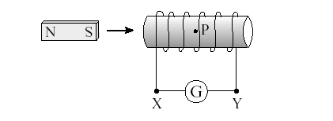
- Ellise takes a laboratory magnet and pushes it into a solenoid?
Why would you expect a current to flow through the solenoid AND in what direction would it flow?

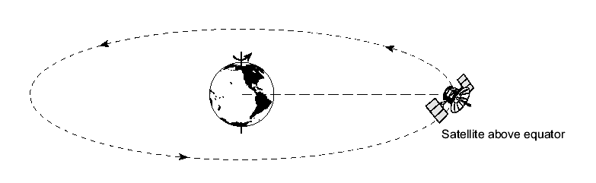
- Geostationary satellites appear to remain stationary to an observer on the Earth. Such satellites are placed in orbit far above the equator.
Explain why such satellite’s all must have the same orbital radius ?

- The movie "Apollo 13" was concerned with a space vehicle which was intended to land on the moon. In making the movie, the film producers had to simulate the apparent weightlessness that was experienced by the astronauts in the space vehicle on the way to the moon. They did this by filming inside an aeroplane which flew in a parabolic path.
Explain how weightlessness arises in the aeroplane flying in the parabolic path described above.

- Two materials, A and B, were tested and the stress versus strain graphs are shown below. The elastic limit of each material is shown as e. The fracture point is indicated as f at the end of each graph.
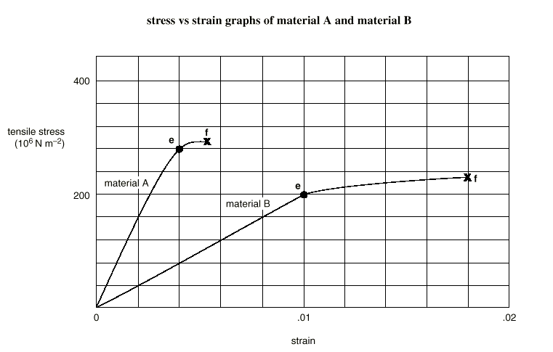 Which one of the two materials (A or B) is tougher? Support your answer with evidence from the graphs.

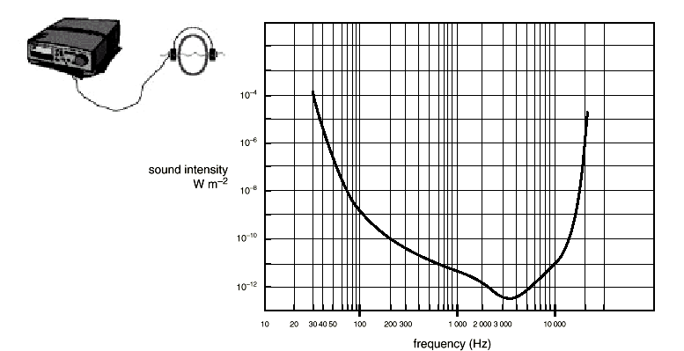
- In an experiment to determine hearing sensitivity, a student uses a set of earphones and a signal generator. For a range of frequencies, he determines the sound intensity (measured at the ear) at which the sound just becomes inaudible. The diagram below shows the sensitivity of hearing of the student.
What range of frequencies can the student hear if the sound intensity at the student’s ear is 1.0 × 10⁻¹¹ W m⁻²?
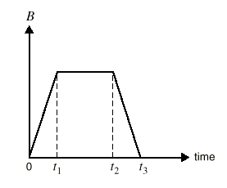
- The on-off action of a lightning stroke produces an electromagnetic field surrounding the stroke. It is this field that causes the crackling in your radio or TV during a thunderstorm. The magnetic field, B, produced by a lightning stroke varies with time as shown below.
A small coil is placed perpendicular to the magnetic field, and the induced emf is monitored on an oscilloscope. Sketch a graph that shows the variation of the induced emf with time?
- A fan that ventilates an underground mine is run by a very large d.c. electric motor. This motor is connected in series with a variable resistor to protect the windings in the coil. When the motor is starting up, the variable resistor is adjusted to have a large resistance. The resistance is then lowered slowly as the motor increases to its operating speed. Explain why no resistance is required when the motor is running at high speed, but a substantial resistance is needed when the motor is starting up.
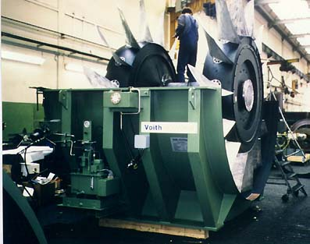
- An organ is constructed so that it has open pipes. A note produced by one of these pipes has a frequency of 280 Hz. The length of this pipe is 1·2 m. A representation of a standing wave corresponding to this note is shown.

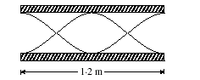
Represented lines

What do the lines that are drawn in the diagram actually represent?

- Explain how a washing machine shown below is able to remove water from clothes when it is spin drying?
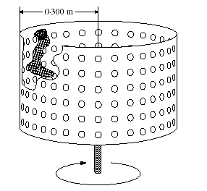

QUESTIONS CONTINUE ON THE NEXT PAGE

SECTION B: Problem Solving

Marks Allotted: 100 marks out of total of 200 marks (50%)

This section contains 7 questions, two of which contain a choice. You should answer
ALL of the questions.

Answer all questions in the spaces provided.

- [14 marks]
Tom is caught on a banked roundabout in East Perth. He is travelling at a steady speed and his situation is shown in the plan and side views below. The car’s speed is such that there is no sideways frictional force between the tryes and the road.
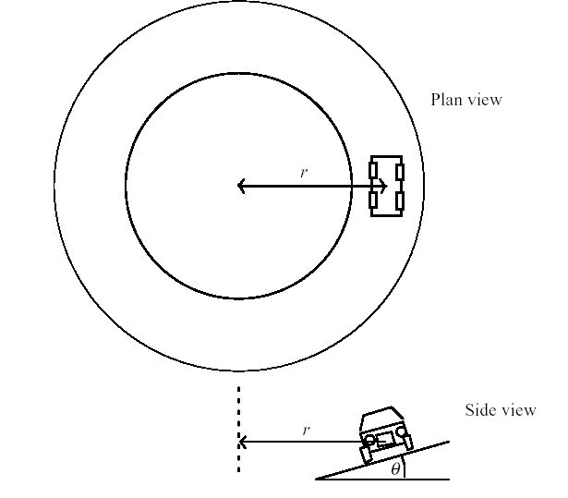
  - Does Toms’ car have an acceleration? Explain your answer. [2 marks]
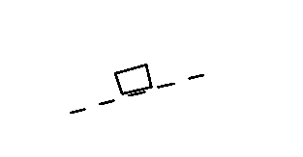
  - We could represent Toms’ car on the roundabout by a block in the diagram below
On the diagram above, draw and label all the forces acting on the moving car?
[3 marks]
  - Is there a resultant force acing on the car? Explain [2 marks]
  - Why is it than engineers when designing roundabouts and freeway off ramps, often bank them?
[2 marks]
  - Using any necessary assumptions, calculate the speed that the car must travel at in order for there to be no sideways frictional force between the tyres and the road?
[3 marks]
  - Suppose now that some oil had been spilled on the roundabout. What effect would this have on Toms’ car if he maintained the speed you calculated in part e)? Explain.
[2 marks]
- [17 marks]
Over the past year or so astronomers have discovered many planets orbiting distant stars. In July this year some Australian astronomers also made a discovery in HD117462. Some of these recent discoveries are shown in the diagram below. In the diagram, M_{JUP} refers to the mass of Jupiter ( 1.90 x 10²⁷ kg). An astronomical unit is the earth- sun distance.
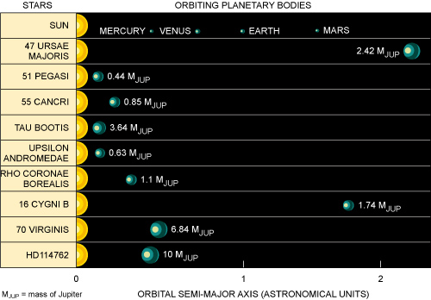
The following data gives the planetary orbital period ‘T’ as a function of distance ‘r’ from the central star 16 Cygni B. Only the first three of several data sets are shown.
The relationship between the data shown above can be summarised by:
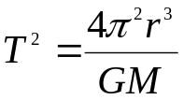
Period, T  (x 10⁵ s) | Radius, r  (x 10⁹ m)
2.43 | 10.0
4.47 | 15.0
6.91 | 20.0

  - If necessary, modify the data above so that you can draw a straight line graph that relates period to orbital radius. If necessary, use the blank columns in the table above to insert your modified data. Explain what you have done.
[5 marks]
  - Plot your modified data on the graph paper below OR write the equation that relates the variables on the graph paper.
[4 marks]

  - Using the graph, determine the mass of the central star 16 Cygni B?
[4 marks]
  - What would you estimate the acceleration due to gravity to be on the planet orbiting 16 Cygni B? List any assumptions that you make.
[4 marks]

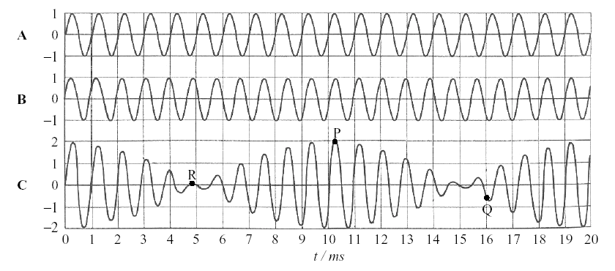
- [16 marks]
Two tuning forks A and B of slightly different frequencies are sounded simultaneously, producing two sound waves of the same amplitude. The figure below shows the disturbance at a particular point in the air as a function of time for each of the tuning forks separately, and the resultant disturbance C.
Three points on the resultant waveform are labelled P, Q and R. For each of these points, check whether the resultant waveform C as drawn is correct, by referring to the two component waves. Explain in each case.
  - Point P
[2 marks]
  - Point Q
[2 marks]
  - Point R
[2 marks]
  - Use the diagram to determine
    - the frequencies of A and B;
[2 marks]
    - the beat frequency.
[2 marks]
  - Beats at this frequency could not actually be perceived as beats by human hearing. Explain why.
[2 marks]
  - In order that the beats become perceived as such by the ear, would the difference in frequency between A and B have to be greater or smaller than in the case above? Explain.
[2 marks]
  - Explain how use could be made of beats to tune a guitar string against a tuning fork.
[2 marks]
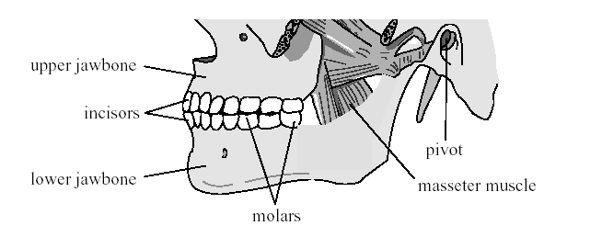
- [11 marks]
The diagram below shows the position of a person’s jawbones. The lower jawbone pivots at one end. The muscle that makes it move is called the masseter muscle.
During biting, the lower jawbone can be represented by the simplified model shown below. It has a horizontal part 7.0 cm in length and a part at a angle from the horizontal, which is 4.0 cm long. The force from the masseter muscle is vertical at the junction of the two parts. Assume the weight of the lower jawbone is negligible.
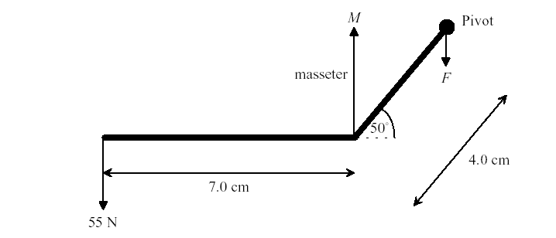
During biting, there is a 55N force on the incisors at the front of the lower jawbone.

  - Calculate the magnitude of M, the force applied by the masseter muscle
[4 marks]
  - Calculate the magnitude of F, the force at the pivot.
[3 marks]
  - Explain why more force can be provided at the molars, during chewing, than at the incisors.
[4 marks]
- 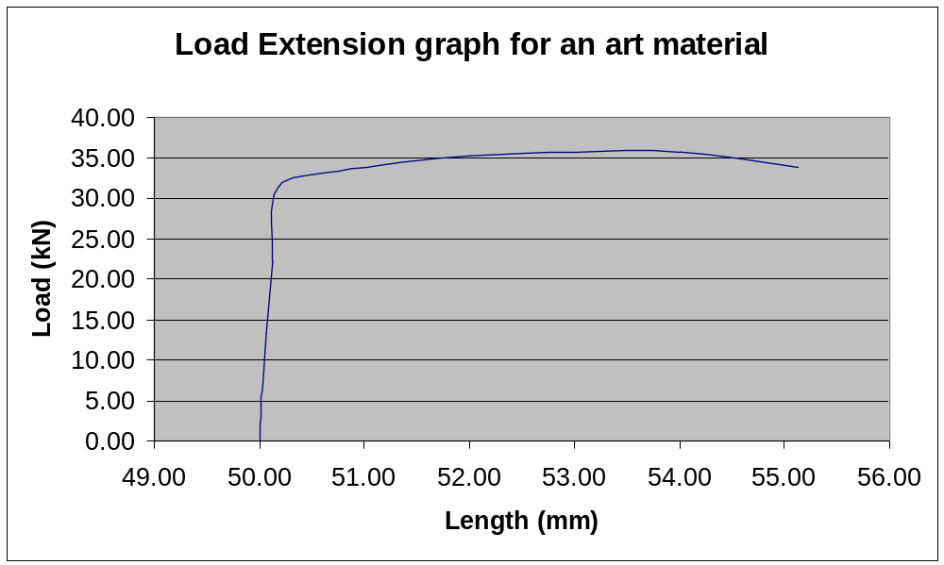[16 marks]
An artist uses some material to support part of a project. The force extension graph of a sample of the material is shown below.
  - Given that material is circular in cross section and has a radius of 3 .00 mm, determine the Young’s Modulus of the material?
[5 marks]
  - Estimate the force that must be applied to store 50.0 J of strain energy in the material?
[2 marks]
  - What material would you expect the wire to made from? Explain.
[2 marks]
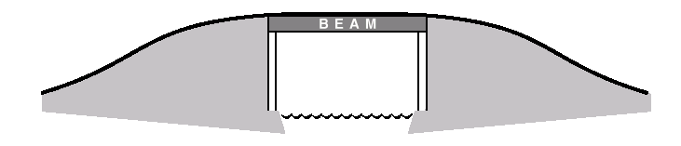
  - Cast-iron beams were once used in bridges to support a roadway as shown below.
Engineers carefully selected the cross-section of bridge beams. They took into consideration
- the forces acting on the beam
- the least mass the beam could have without reducing safety
- the fact that cast iron is stronger under compression than under tension.
Diagrams A–D represent possible cross-sections of the beam. Which one of the following cross-sections would an engineer select as most appropriate for the cast-iron beam? Give reasons for your answer.

[2 marks]
  - Consider a simple beam bridge made of cast iron, that needs to span a river 6.0 m wide. If the beam has a mass of 850 kg and you stand 2.0 m from one end, what would you estimate to be the vertical forces that the ground needs to exert on the ends of the bridge. List any assumptions that you make?
[3 marks]

  - There are some problems in using stone for this type of construction in the same way that the cast iron. Explain how an engineer could span this river using stone and why this particular design is chosen?
[2 marks]
- [14 marks]
Max and Michelle are buying loudspeakers for their hi-fi. They are choosing between two models, a 35-cm diameter speaker (P), and a 5-cm one (Q). Both speakers operate equally well over the complete audible frequency range. Max is standing in front of the speakers, and Michelle is the same distance away, but to one side, as shown below.
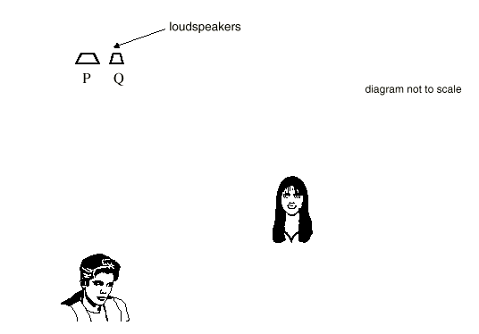
As a test of the speakers they play sounds of 10 000 Hz and 200 Hz, and compare the intensity that they each hear.

  - The wavelength of sound of frequency 200 Hz is 1.65 m. What is the wavelength of sound of frequency 10 000 Hz?
[2 marks]

Max comments that the intensity of the sound of both frequencies seems the same from either speaker. However Michelle says that for the larger speaker, the 10 000-Hz sound is significantly softer than the low frequency sound.
  - In the space below, explain these observations. Include relevant calculations and/or diagrams to support your reasoning.
[4 marks]
In the end, they decided to buy two of the 5cm model. When they got them home, instead of listening to Ja Rule and dancing, they decided to try out an experiment. They connected the speakers to the same output on the CD player, placed the speakers 12.0 m apart and put on their single frequency CD (ie a CD that produces sound of a single frequency)
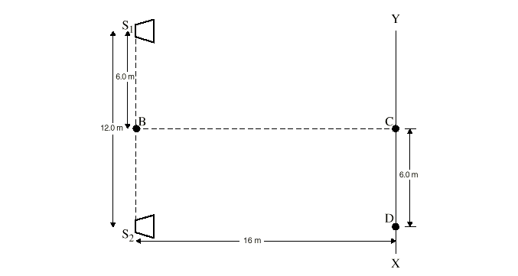
  - What happens to the sound intensity as Michelle walks from point C to point B? Explain your answer
[2 marks]
Michelle now walks from point C towards X. She detects maxima and minima in the sound intensity. At the point D she detects the second minimum after leaving point C.

  - What is the wavelength of the sound produced by the loudspeakers? Show your working.
[4 marks]
  - Max notices that some of the decorative plates that are on his desk begin to vibrate? Explain this observation
[2 marks]
- [12 marks]
The diagram below shows some of the energy levels inside a mercury atom.
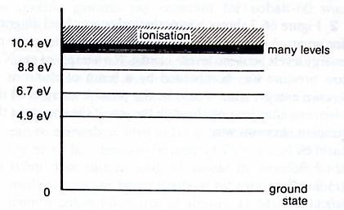
  - How many lines would you expect this atom to show in its
    - Absorption spectrum [2 marks]
    - Emission spectrum [2 marks]
    - Determine the frequency of one of the lines in the emission spectra
[2 marks]
  - Suppose a beam of electrons of energy 9.9 eV pass through mercury vapour, what could be the possible energies of the emerging electrons?
[3 marks]
  - What actually happens to the energy the electrons lose? Be specific and support your answer with a calculation.
[3 marks]
SECTION C: Comprehension and Interpretation.

This section contains 2 questions and is worth 20% (40 marks out of 200) of the marks for the examination. Answer both questions in this section.

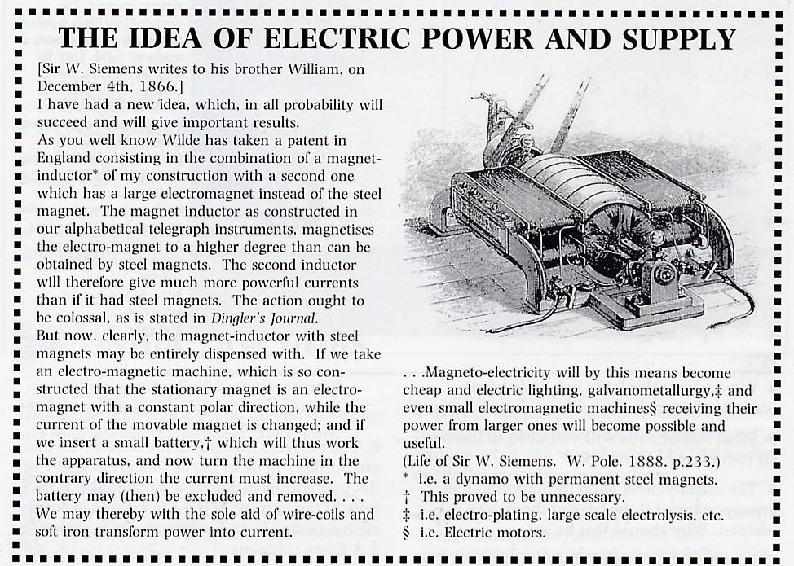
  - Describe the generator that Siemans is proposing?
[3 marks]
  - Why do you think that the battery can be removed once the machine is moving? Explain [2 marks]
  - What advantages did Siemens see for society with the development of his generator?
[3 marks]
  - Why is the soft iron considered to be more effective than the steel?
[2 marks]
  - How could Siemans have increased the emf produced?
[3 marks]
  - When does Siemens’ generator produced its maximum emf? Explain
[3 marks]
  - To deliver power from generators used today, high voltages are used. Explain why high voltages are used and how the voltage changes occur?
[4 marks]
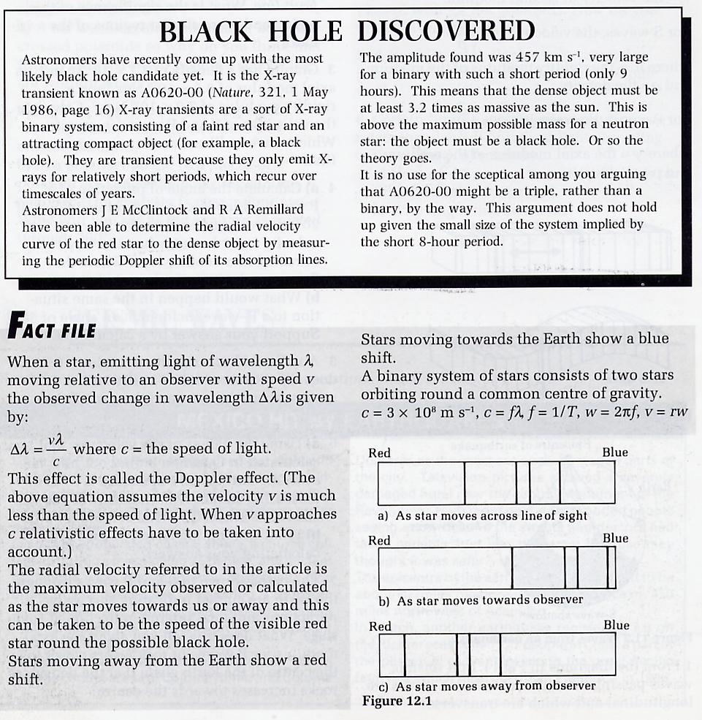
  - Given that stars moving towards the earth show a blue shift, what would you expect to happen to the wavelengths of X-rays from an X-ray transient star as it is moving away from an observer?
[4 marks]
  - If the X-ray transient star emits X-rays of frequency 10¹⁹ Hz, calculate the wavelength of the X-rays emitted?
[3 marks]
  - Determine the change in wavelength as the star moves towards or away from an observer? (Use the maximum amplitude of the radial velocity)
[4 marks]
  - The spectrum of a star has characteristic dark lines across it? What is the origin of these dark absorption lines?
[4 marks]
  - During a total eclipse of the sun, the dark absorption lines of our sun become bright emission lines. Why does this happen?
[3 marks]
  - Astronomers have been hunting black holes for a number of years, but not that many have been found. What do you think are the main properties of black holes that makes the search so difficult?
[2 marks]
END OF EXAM

